***“To develop an android application for language translation that facilitates the user to understand unknown languages.”***

**A Project Report Submitted to**

**Rajiv Gandhi Proudyogiki Vishwavidyalaya**



**Towards Partial Fulfillment for the Award of**

**Bachelor of Engineering in Computer Science Engineering**

***Submitted by:***

***Guided by:***

**Samagra Shrivastav (0827CS201213)**

**Somil Garg(0827CS201244)**

**Sidhant kumar (0827CS201242)**

**Sourabh chouhan(0827CS201245)**

**Prof. Ankit Jain**

**Professor, CSE**

**AITR, Indore**



***Acropolis Institute of Technology & Research, Indore***

**July - Dec 2022**

EXAMINER APPROVAL

The Project entitled “**To develop an android application for language translation that facilitates the user to understand unknown languages.”**submitted by **Samagra Shrivastava (0827CS201213) , Somil Garg (0827CS201244) ,****Sidhant Kumar (0827CS201242) , Sourabh Chouhan (0827CS201245)** has been examined and is hereby approvedtowards partial fulfillment for the award of **Bachelor of Technology** **degree in Computer Science Engineering**discipline, for which it has beensubmitted. It understood that by this approval the undersigned do not necessarily endorse or approve any statement made, opinion expressed or conclusion drawn therein, but approve the project only for the purpose for which it has been submitted.

**(Internal Examiner)** **(External Examiner)**

**Date:** **Date:**

GUIDE RECOMMENDATION

This is to certify that the work embodied in this project entitled **“To develop an android application for language translation that facilitates the user to understand unknown languages**.**”**submitted by**Samagra Shrivastava (0827CS201213) , Somil Garg (0827CS201244) , Sidhant Kumar (0827CS201242) , Sourabh chouhan(0827CS201245)** is asatisfactory account of the bonafide work done under the supervision of **Dr. Kamal Kumar Sethi**, is recommended towards partial fulfillment forthe award of the Bachelor of Technology (Computer Science Engineering) degree by Rajiv Gandhi Proudyogiki Vishwavidhyalaya, Bhopal.

**(Project Guide)** **(Project Coordinator)**

STUDENTS UNDERTAKING

This is to certify that project entitled **“To develop an android application for language translation that facilitates the user to understand unknown languages.”** has developed by us under the supervision of**Dr. Kamal Kumar Sethi**. The whole responsibility of work done in this project is ours.The sole intension of this work is only for practical learning and research.

We further declare that to the best of our knowledge; this report does not contain any part of any work which has been submitted for the award of any degree either in this University or in any other University Deemed University without proper citation and if the same work found then we are liable for explanation to this.

**Samagra Shrivastava (0827CS201213)**

**Somil Garg (0827CS201244)**

**Sidhant Kumar (0827CS201242)**

**Sourabh Chouhan (0827CS201245)**

Acknowledgement



We thank the almighty Lord for giving me the strength and courage to sail out through the tough and reach on shore safely.

There are number of people without whom this projects work would not have been feasible. Their high academic standards and personal integrity provided me with continuous guidance and support.

We owe a debt of sincere gratitude, deep sense of reverence and respect to our guide and mentor **Dr. Kamal Kumar Sethi,** Professor, AITR, Indore for his motivation, sagacious guidance, constant encouragement, vigilant supervision and valuable critical appreciation throughout this project work, which helped us to successfully complete the project on time.

We express profound gratitude and heartfelt thanks to **Dr Kamal** **Kumar Sethi**, Professor & Head CSE, AITR Indore for his support, suggestion, andinspiration for carrying out this project. I am very much thankful to other faculty and staff members of IT Dept, AITR Indore for providing me all support, help and advice during the project. We would be failing in our duty if do not acknowledge the support and guidance received from **Dr S C** **Sharma**, Director, AITR, Indore whenever needed. We take opportunity toconvey my regards to the management of Acropolis Institute, Indore for extending academic and administrative support and providing me all necessary facilities for project to achieve our objectives.

We are grateful to **our parent** and **family members** who have always loved and supported us unconditionally. To all of them, we want to say “Thank you”, for being the best family that one could ever have and without whom none of this would have been possible.

Executive Summary



**To develop an android application for language translation that facilitates the user to understand unknown languages.”**

This project is submitted to Rajiv Gandhi Proudyogiki Vishwavidhyalaya, Bhopal (MP), India for partial fulfillment of Bachelor of Engineering in Information Technology branch under the sagacious guidance and vigilant supervision of **Dr. Kamal Kumar Sethi**.

Today, translation is more widespread and accessible than ever before. Translation efforts can be organized in creative ways: organizations with larger budgets may choose to hire a translation company or independent professional translators to handle all of their translation needs; organizations with smaller budgets, or with subject matter that is not familiar to many translators, may decide to combine the services of professional translators with the skills of existing staff members; finally, organizations with a pool of expert volunteers may opt to include their services in the process. Whatever your budget and translation needs, there are ways to make it work.

*“Where the vision is one year, cultivate flowers;*

*Where the vision is ten years, cultivate trees;*

*Where the vision is eternity,*

*cultivate people.” - Oriental Saying*

Table of Contents



|  |  |  |
| --- | --- | --- |
| **CHAPTER 1 .** | **INTRODUCTION ...........................................................................** | **11** |
| 1.1 | Overview ............................................................................... | 12 |
| 1.2 | Background and Motivation ................................................. | 13 |
| 1.3 | Problem Statement and Objectives ...................................... | 14 |
| 1.4 | Scope of the Project .............................................................. | 15 |
| 1.5 | Team Organization ................................................................ | 16 |
| 1.6 | Report Structure ................................................................... | 17 |

|  |  |  |
| --- | --- | --- |
| **CHAPTER 2 .** | **REVIEW OF LITERATURE .........................................................** | **19** |
| 2.1 | Preliminary Investigation ...................................................... | 20 |
|  | 2.1.1 Current System ................................................................. | 20 |
| 2.2 | Limitations of Current System .............................................. | 21 |
| 2.3 | Requirement Identification and Analysis for Project ........... | 22 |
|  | 2.3.1 Conclusion ...................................................................... | 22 |

|  |  |  |  |
| --- | --- | --- | --- |
| **CHAPTER 3 .** | **PROPOSED SYSTEM .................................................................** | | **23** |
| 3.1 | The Proposal ....................................................................... | | 23 |
| 3.2 | Benefits of the Proposed System........................................ | | 23 |
| 3.3 | Block Diagram ..................................................................... | | 25 |
| 3.4 | Design Representation........................................................ | | 26 |
| 3.5 | Deployment Requirements ................................................. | | 27 |
|  | 3.6.1 | Hardware ........................................................................ | 27 |
|  | 3.6.2 | Software.......................................................................... | 27 |

|  |  |  |  |
| --- | --- | --- | --- |
| **CHAPTER 4 .** | **IMPLEMENTATION ..................................................................** | | **28** |
| 4.1 | Technique Used .................................................................. | | 28 |
|  | 4.1.1 | Google Trans ............................................................... | 28 |
|  | 4.1.2 | Translate : ........................................................... | 30 |
| 4.2 | Tools Used ........................................................................... | | 31 |
|  | 4.2.1 | OCR .................................................................... | 31 |
|  | 4.2.2 | Android Studio .............................................................. | 33 |
| 4.3 | Language Used .................................................................... | | 35 |
| 4.4 | Screenshots ......................................................................... | | 37 |
| 4.5 | Testing ................................................................................. | | 38 |
|  | | | |

|  |  |  |
| --- | --- | --- |
| **CHAPTER 5 .** | **CONCLUSION...............................................................................** | 39 |
| 5.1 | Conclusion ........................................................................... | 39 |
| 5.2 | Limitations of the Work ...................................................... | 39 |
| 5.3 | Suggestion and Recommendations for Future Work ......... | 40 |
| **BIBLIOGRAPHY** | **..........................................................................................................** | **40** |

**PROJECT PLAN…………………………………………………………………………………44**

**GUIDE INTERACTION SHEET…………………………………………………………...45**

**SOURCE CODE………………………………………………………………………………….46**

**Chapter 1. Introduction**

Introduction



Traditional method of attendance marking is a tedious task in many companies. It is also an extra burden to the manager who should mark attendance by manually calling the names of company which might take about 5 minutes of entire session. This is time consuming. There are some chances of proxy attendance. Therefore, many companies started deploying many other techniques for recording attendance like use of Radio Frequency Identification (RFID) [3], iris recognition [4], fingerprint recognition, and so on. However, these systems are queue based which might consume more time and are intrusive in nature. Face recognition has set an important biometric feature, which can be easily acquirable and is non-intrusive. Face

Recognition based systems are relatively oblivious to various facial expression. Face recognition system consists of two categories: verification and face identification. Face verification is an 1:1 matching process, it compares face image against the template face images and whereas is an 1:N problems that compares a query face images [1]. The purpose of this system is to build a attendance system which is based on face recognition techniques. Here face of an individual will be considered for marking attendance. Nowadays, face recognition is gaining more popularity and has been widely used. This new system will consume less time than compared to traditional methods.

* 1. **Overview**

Attendance Management System basically has two main modules for properfunctioning.

 Admin module is has rights for creating any new entry of faculty andstudent details.

 User has a rights of making daily attendance, generating report.Attendance report can be taken by given details of student details,date, class.

**1.2 Background and Motivation**

Translation is one of simple and effective ways to understand another language easily In order to understand the message from another text accurately, a translator should have knowledge both source and target language. Therefore, a deep understanding of translation will help in doing a good translation text.

Many books that have been translated into Indonesian language spread everywhere whether in book shop or book market. For instance, the translator translates not only the scientific.

The technology books but also literary work. Those translation of technology, scientific and literary books prove that translation in Indonesia is growing more and more, and hopefully that those will be better.

It is not easy to translate whether scientific or literary books. It deals with the process of rendering the message and finding the accuracy and equivalent message of Source Language (SL) into Target Language (TL). By enriching vocabulary, a translator hopes he can produce a good translation

**1.3 Problem Statement and Objectives**

**”To develop an android application for language translation that facilitates the user to understand unknown languages”**

The goal of translation practice for non-specialists is to found the language skills of the learner, to refine their thematic and cultural knowledge and to encourage them to think and to react.

Thus, the system implemented has the following objectives :

**1. Develop a system which able to do conversion between the languages.**

**2. Provide an easy and simple for translation.**

**3 Endow good experience to the user.**

**4. Translate almost each language.**.

**1.4 Scope of the Project**

The future of translation will cover more cultures, as the internet continues to penetrate in emerging countries worldwide. Besides the top languages for translation , the software will have to provide accurate solutions to communicate with audiences who speak lass known dialects.

* Students who belongs from different states those can use for communication purpose.
* Tourists can use for guide.
* For learning purpose.

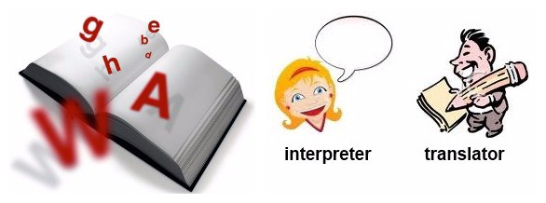





**1.5 Team Organization**

* **Samagra Shrivastava (Team leader):**

Along with doing preliminary investigation and understanding the limitations of current system, I studied about the topic and its scope and surveyed various research papers related to the technology that is to be used. I also worked on the implementation of google translate and the working of project. Worked on creating database for storing results in database. Documentation is also a part of the work done by me in this project.

* **Somil Garg :**

I investigated and found the right technology and studied in deep about it. For the implementation of the project , I collected the object data and trained the model for it. Implementation logic for the project objective and coding of internal functionalities is also done by me. Also, worked on Back end design for storing results in database for maintaining logs.

* **Sidhant Kumar :**

I worked on the technology and implementation of the project , I collected the object data and trained the model for it. Implementation logic for the project objective and coding of internal functionalities is also done by me.

* **Sourabh Chouhan :**

I worked in front end and I studied about the topic and its scope and searched various research papers related to the technology that is to be used.

**1.6 Report Structure**

The project “**To develop an android application for language translation that facilitates the user to understand unknown languages.”** is primarily concerned with the translator and whole project report is categorized into five chapters.

**Chapter 1: Introduction** - introduces the background of the problem followed by rationale for the project undertaken. The chapter describes the objectives, scope and applications of the project. Further, the chapter gives the details of team members and their contribution in development of project which is then subsequently ended with report outline

.

**Chapter 2: Review of Literature** - explores the work done in the area of Project undertaken and discusses the limitations of existing system and highlights the issues and challenges of project area. The chapter finally ends up with the requirement identification for present project work based on findings drawn from reviewed literature and end user interactions.

**Chapter 3: Proposed System** - starts with the project proposal based on requirement identified, followed by benefits of the project. The chapter also illustrate software engineering paradigm used along with different design representation. The chapter also includes block diagram and details of major modules of the project. Chapter also gives insights of different type of feasibility study carried out for the project undertaken. Later it gives details of the different deployment requirements for the developed project.

**Chapter 4: Implementation** - includes the details of different Technology/ Techniques/ Tools/ Programming Languages used in developing the Project. The chapter also includes the different user interface designed in project along with their functionality. Further it discuss the experiment results along with testing of the project. The chapter ends with evaluation of project on different parameters like accuracy and efficiency.

**Chapter 5: Conclusion** - Concludes with objective wise analysis of results and limitation of present work which is then followed by suggestions and recommendations for further improvement.

**Chapter 2 . Review of Literature**

Review of Literature



Digitalizing the Old Approach Traditional student attendance involves all the roll-calling issues and takes a lot of time for students and teachers to conduct departmental sessions. The procedure is lengthy and takes many instructors’ and students’ time. Mendonca et al. [20] reduced the length of the complete attendance verification by designing an online system. Substituting the conventional procedure, teachers had to call each student’s name in class and note the attendance when the student answered. It offers a more straightforward and quicker approach to monitoring attendance. Instructors will no longer require a paper sheet to mark student attendance in their proposed system. They can construct attendance records by obtaining the necessary information from the database, making the entire procedure paperless. Another Research used mobile devices in the attendance management system were developed and put into practice. A mobile-based attendance management program for Android systems was developed using VB.NET and SQL Server. This project allows for the maintenance of student attendance, calculating attendance grades, and creating a report. Five components make up the system: admin, registration, student, SMS, and an Android component. Students can use the android part to send messages to the system informing lecturers of their absence. Parents can also get SMS notifications on students’ behavior [19]. B. Fingerprint Recognition Based Most of the research has demonstrated that fingerprint or hand gesture recognition is a highly suitable method for an attendance management system. The method of digitally comparing one or more unknown fingerprints to a collection of known and unknown fingerprints in the database is known as automated fingerprint recognition. A particular finger assumption device that is used as a component of a special finger impression attendance framework was described by Mohamed and Raghu [3]. The students may check their essence by placing their fingertips on the device's sensor. But because fingerprint scanners can’t always identify something the first time, this framework lacks viability. Soewito et al. [4] presented an attendance system employing smartphone GPS and fingerprint technologies. The method takes a lot of time since it makes use of fingerprint recognition. Fig. 1 General Architecture of Fingerprint Recognition C. GPS-based Attendance System Global Positioning System, or GPS, enables us to determine a person’s location and direction at any time, any place on Earth. In terms of knowing where humans are and how to go to other areas, people still

Bawar Ali Abdalkarim and Devrim Akgün, A Literature Review on Smart Attendance Systems, ICAENS 2022, Konya, Turkey 1570need objects in the sky, but now satellites utilize them. In their work, Kumar and Kumar [12] presented a creative location-based time and attendance monitoring system that was deployed on an Android mobile app. The use of smartphones helps to reduce the need for additional biometric scanning equipment. Components of the organization include a specific location, which may be located using GPS. The GPS on mobile phones determines each student’s place, and these locations are crucial for some time and attendance tracking. D. Barcode / QR code Based An associated barcode is a graphical way to represent data that machines regarding the item can read. A quick Response Code, sometimes known as a QR code, is comparable to a barcode. However, it holds data in both two perpendicular directions because of its two-dimensionality. As a result, a QR code may store several times more data than a barcode. Discussing a system for automating student attendance was introduced by Noor et al. [9]. Everyone in this system has a unique ID that is assigned a barcode that the mobile app can scan. Each user in this system has an individual ID with a barcode that the mobile app may scan. One of the drawbacks of this approach was that a single student may trick it by using the IDs of the other students in the arrangement. Another approach depends on gathering attendance and updating data in one area. The suggested method, which was built utilizing QR code technology and is based on research by Sutar et al. [11], is a smart attendance system that would speed the attendance process by creating and scanning QR codes. The system runs as an application on mobile devices and is built on QR Technology. Moreover, to assure student attendance in the course, Sunaryono et al. suggest “an Android-based course attendance system using face recognition.” [10]. The course information is encoded into a QRcode and presented from the front of the class. The student is just required to use their phone to take a photo of their face and display a QR code. The picture will subsequently be transmitted to the server to manage the attendance. E. Face Recognition Based The idea of finding human faces in referenced photographs or videos is known as face detection. A face recognition system is a type of tech that can compare face images from a video or photograph to a database of known and unknown faces. The Face, Recognition-based Attendance Management System, was developed by Smitha to develop an organized classroom attendance system using face recognition methods [6]. Through facial ID, the system can record involvement. Through a camera, it finds faces and then recognizes them. The system is split into two parts: facial recognition and detection. Using the Local Binary Pattern Histogram (LBPH), the system will identify faces of students in the live-streamed video from the class and, if the recognized face is found in the database, will mark their attendance. Face recognition technology was also discussed by Varadharajan et al. in their paper. They placed a camera inside the class, using this technique to take pictures. The attendance is registered as a present after faces are found and identified in the database. Parents are informed of a student’s disappearance if their attendance is noted as absent [5]. The research by Chandramouli et al. [13], wherein they utilized NVIDIA’s Jetson Nano, is one of many that tries to modernize how attendance is managed in a certain method and even the parameters for time management. The device is set in the class, where the names and photos of the students are held. Open CV is used to obtain the photos. The processor board would be NVIDIA Jetson Nano’s Developer kit. A Haar classifier is used to identify faces once the extraction has been processed. They subsequently identified with the aid of the LBPH Algorithm. An Excel spreadsheet is generated and refreshed hourly with data from the appropriate class teacher. Ofualagba et al. [7] suggested a system named Automated Student Attendance Management System Using Face Recognition that highlights the use of Cloud Computing (CC) technological concepts to boost the performance of face identification methods. The FACECUBE system, which is suggested here, uses facial recognition to take attendance. The system provides students, instructors, and administrators with online features. However, putting this system together involves several steps, including purchasing new hardware and software. Susanto et al. [21] were attempted to perform a slightly different type of research concerning the detection of face recognition of lecturers who are present in the application system via an Android device. They make a connection with face recognition detection and, after that, save it to the database that was used as information about the presence of lecturers who are teaching. The local binary pattern histogram (LBPH) classifier approach, which may be used as a strategy in the attendance system of lecturers to be more efficient and productive, is used to evaluate the facial recognition system. An open-source, generic application for assessing daily attendance using face recognition and making use of the Android system was proposed in the Hava et al. [22] study. Almost every institution may readily get it at no cost. With this suggested solution, Google Sheets are automatically created and available to the institution with no effort. The system involves facial identification and recognition algorithms to identify individual students and record their participation. Prangchumpol mentions in his research, "Face Recognition for Attendance Management System Using Multiple Sensors,"[14] that his performance still falls short when it comes to accurately identify students' faces and that he is still unable to confirm or rectify the data when a mistake occurs in class. Therefore, he seeks to improve the efficiency of the face recognition-based attendant system and make the system's principles simple for students to understand. This sort of validation aims to discover how to detect faces utilizing the Android Face Recognition with Deep Learning approach. The database is linked to the web server using cloud storage. Alburaiki et al. [8] developed a methodology that solved three key elements: First, using mobile phone cameras and automatically recognizing and analyzing faces. The second is a machine-learning-based facial recognition API. Lastly, maps API. The outcome demonstrates that face recognition has attained high accuracy in identifying students' faces even in unfavorable conditions. The system displayed practical examples of responses by marking the student's attendance after identifying the student's face and location, as well as the lecturer has the option to access a report of submitted attendance. A portable attendance system that could be accessed from any location at any time inspired Salac's study [23]. Without carrying paper and PCs, the lecturer may simply verify attendance using an Android smartphone. The students' Android phones make it simple for them to check their attendance information. Additionally, SMS technology is employed to ensure the safety of the students and to notify families about their child's attendance. Face recognition is also used to establish a proper attendance record. A particular student's face is detected and recorded as present in the database using the Android device's camera. When necessary, attendance reports could also be formed. Fig. 2 Fundamentals of Face Recognition Process F. Android-Based Authorized ID and Password Android OS was developed mainly for touch mobile devices. It is based on a slightly different version of the Linux kernel and other open-source applications. You can be prompted to sign up or sign in each time you use an android-based smartphone and visit an application or website. Typically, a login/password creation request can be made for you. Now that this procedure is so popular, some users may register their accounts without giving attention to their password because it has practically become part of the routine. Unfortunately, if a user picks poor credentials, there is much risk. Hameed [17] developed and put into use an intelligent Android-based attendance system. The technology creates attendance data automatically and offers a quicker, more economical, and accessible solution for tracking online student attendance. The three characteristics of the attendance system are the admin account, which can log in and change the database; the instructor account, which can mark students as the present; and the reporter which can verify attendance records and report all duties. The course instructor will be ready to obtain attendance with ease using phones with Android OS which has been developed to save attendance both on the device and servers, as well as to Verify statistics and print a paper version according to Islam et al. [24] paper. Their system can record attendance, mark invaders' admission, calculate attendance percentages, and send emails and Text

**2.1 Preliminary Investigation**

**2.1.1 Current System**

While it is primarily a tool used for translation for text, today Translate can be used for a lot more than just basic text translations. Today, it is commonly used for the following translation services and needs:

* **Translation of the written word.**The most common use of the tool, allowing for over 109 languages to be translated with near-perfect accuracy, and many other languages with increasing accuracy.
* **Translation of entire documents.**Instead of having to translate the document line-for-line, Translate allows for the document to be uploaded and translated in a much shorter timeframe.
* **Translation of mobile applications**. By using a “Tap to Translate” feature, users can take a foreign language application and translate it as best as possible in the needed language.
* **Translation of imagery.**Today, Translate could also be used to translate the text that is found within an image, translating the text as best as is possible into your needed language.
* **Translation of spoken content**. While still in development and improvement phases, you can also use Translate to live-translate a spoken line of words from someone.

**2.2 Limitations of Current System**

* The complexity of the text, as well as any context which cannot be interpreted without a true knowledge of the language, makes the likelihood of errors greater. Direct translation is common with Google Translate and often results in nonsensical literal translations while professional translators take great pains to ensure that this does not happen by using well-established online glossaries, back translation methods, proof readers and reviewers.
* Which source and target languages are involved also affects the quality of the translation. Since Google’s web-based translation database is built primarily from existing online translations, common translations for languages e.g. Spanish or English tend to be more accurate while translations for other languages that are not as available in Google’s database are less likely to be accurate.
* This is due to the fact that Google’s translation system uses a method based on language pair frequency that does not take into account grammatical rules.

**2.3.1 Conclusion**

In the existing system, we have google translator which utilizes internet connectivity whereas internet may not be available all the time.

And there are also many android application available that may not support all the functionalities like scanning text, speech recognition and translates the text and which are applicable for specific and limited languages which are not useful for all the users.

So here in the proposed system where we will be implementing translation with support all the functionalities like scanning text, speech recognition and translates the text and includes the languages which are popular in our country as well as popular all over the world.

**Chapter 3 . Proposed System**

Proposed System



**3.1 The Proposal**

The proposal is to make a application that plays a very important role in making applications available to the people of your area. If your app can translate into the locally spoken languages, it will have a better audience reach. As accessibility increases, the popularity of the application will too.

**3.2 Benefits of the Proposed System**

The current system had a lot of challenges that are overcome by this system :

* **Traveling to other countries.**Navigating your way in other countries can be exciting and challenging, with one of the biggest challenges being the language barrier. Using translation apps can help with simple requests, like getting directions, ordering food, or reading signs. With [79 million](https://www.statista.com/statistics/214774/number-of-outbound-tourists-from-the-us/) U.S. citizens traveling abroad in 2019, translation apps for travelers is clearly a vital service.
* **Helping as you learn a new language.**As more people continue to want to learn [new languages](https://www.babbel.com/en/magazine/why-learn-languages), translation apps can assist with their endeavor. While a translation app cannot replace actual learning, it can help overcome some of the language difficulties.
* **Talking with prospective clients.**In our global economy, many companies have prospective clients throughout the world. If someone is interested in your product or service, being able to communicate with them in their language is vital. Having a translation app means that you can efficiently look up the right words to say to communicate your message.
* **Participating in global meetings.**In your business, you might need to have large group meetings with employees across the globe. Whether the meeting is in person or virtual, having an app to translate the conversation would be useful.

**3.3 Block Diagram**

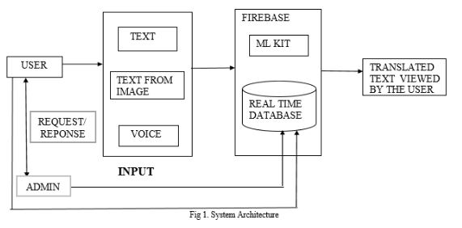

**Figure 3-1 : Block Diagram**

***Real-Time Object Detection and Recognition***

**Data Flow Diagrams**

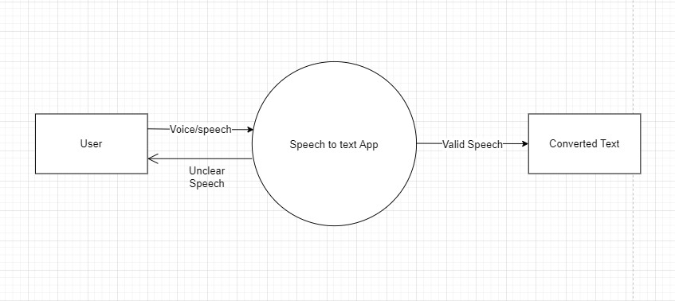

 **Figure 3-7 Data Flow Diagram Level 0**

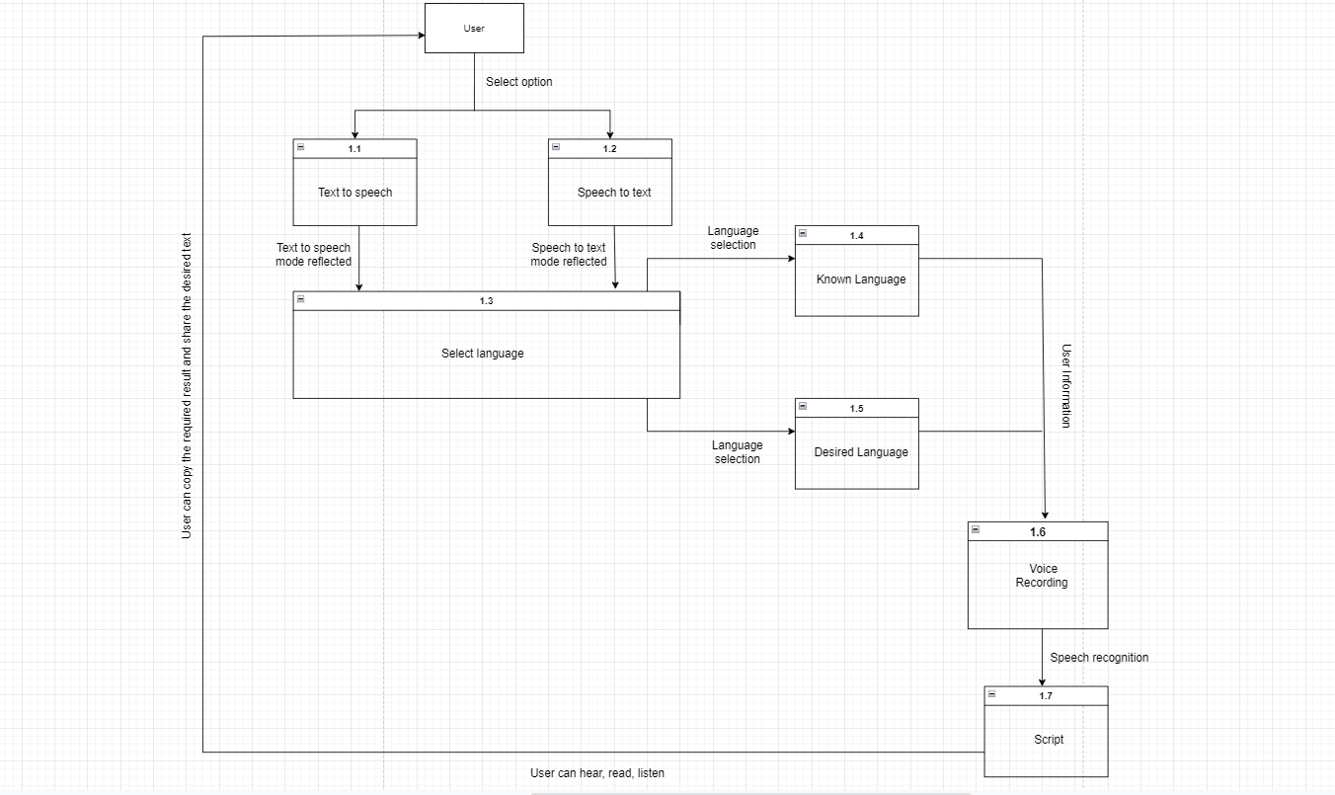 **Figure 3-8 Data Flow Diagram Level 1**

***Real-Time Object Detection and Recognition***

**3.6 Deployment Requirements**

There are various requirements (hardware, software and services) to successfully deploy the system. These are mentioned below :

**3.6.1 Hardware**

* A good processor
* Storage up to 2 GB or above
* Required RAM: 2 GB or above
* Active internet connection

**3.6.2 Software**

* Google Trans
* Java and its supported libraries
* Android Studio

***Real-Time Object Detection and Recognition***

**Chapter 4 . Implementation**

Implementation



For the problem of counting the number of students and vehicles entering the college campus manually, the system is designed in such a way so as to automate the process by placing a camera at the entrance gate so that students, bikes and cars getting inside the college campus can be identified and counted.

**4.1 Technique Used**

**4.1.1 Google Trans**

Google Translate is a product of the world’s foremost Internet company, so it’s no surprise that it is highly popular and relied upon by most Internet users worldwide. When you talk about the best online translation apps, it’s difficult not to quickly associate it with this translator app by Google. It is even in the Reference category of apps in the iOS App Store.

Google Translate has one of the most advanced if not the most advanced [free translation software](https://www.daytranslations.com/free-translation-online/). The great tech is what makes Google Translate one of the most popular translation apps in the world as it can be used for formal and informal speech.

It is the result of years of development and the most recent relevant technological advancements.

These manifest in the extensive range of features the app offers. It can translate text into more than 100 languages and is even capable of offline translations in multiple languages (59 to be exact).

Additionally, it can translate text and numbers as taken by a device’s camera (camera translation) or by analyzing a photo or image fed into the app (not taken by the camera).



**4.1.2 Translate :**

Developed by the Russian equivalent of Google, Yandex. Translate is a powerful language translation mobile application that supports 95 languages when online. Offline, the app remains useful as it can also perform translations to English from the following languages: French, German, Italian, Russian, Spanish, and Turkish.

When it comes to speech translation, Yandex. Translate does not come close to rivaling the big guns as it only supports four languages: English, Russian, Ukrainian, and Turkish.

Nevertheless, the app can be made to read aloud the text translations it generates. This feature-rich translation app on phones running Android or iOS (and even your apple watch) is also capable of performing camera or image translations for 12 languages, namely English, French, Czech, German, Russian, Spanish, Portuguese, Chinese, Turkish, Polish, and Ukrainian.



***Real-Time Object Detection and Recognition***

**4.2 Tools Used**

**4.2.1 OCR**

Optical character recognition (OCR) technology is a business solution for automating data extraction from printed or written text from a scanned document or image file and then converting the text into a machine-readable form to be used for data processing like editing or searching.

A common application of OCR technology is the automated conversion of an image based PDF, TIFF or JPG into a text based machine-readable file. OCR-processed digital files, such as receipts, contracts, invoices, financial statements and more, can be:

* Searched from a large repository to find the correct document
* Viewed, with search capability within each document
* Edited, when corrections need to be made
* Repurposed, with extracted text sent to other systems

OCR capabilities, the ability to extract machine-printed text from a digital image, is only one aspect of a [data capture solution](https://www.hyland.com/en/platform/capabilities-and-features/capture). Data can be extracted from documents in many different formats—hand printed text (ICR), check boxes (OMR), bar codes, etc.

Businesses that employ OCR capabilities to convert images and PDFs (typically originating as scanned paper documents) save time and resources that would otherwise be necessary to manage unsearchable data. Once transferred, OCR-processed textual information can be used by businesses more easily and quickly.

The benefits of OCR technology to businesses include:

* Elimination of manual data entry
* Resource savings due to the ability to process more data faster and with fewer resources
* Error reductions
* Reallocation of physical storage space
* Improved productivity

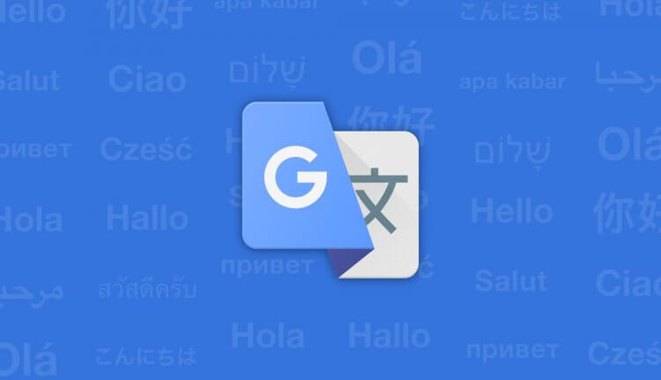

**4.4.2 Android Studio**

**Android Studio** is the official Integrated Development Environment (IDE) for android application development. Android Studio provides more features that enhance our productivity while building Android apps.

Android Studio was announced on 16th May 2013 at the Google I/O conference as an official IDE for Android app development. It started its early access preview from version 0.1 in May 2013. The first stable built version was released in December 2014, starts from version 1.0.

Since 7th May 2019, Kotlin is Google's preferred language for Android application development. Besides this, other programming languages are supported by Android Studio.

**Features of Android Studio**

* It has a flexible Gradle-based build system.
* It has a fast and feature-rich emulator for app testing.
* Android Studio has a consolidated environment where we can develop for all Android devices.
* Apply changes to the resource code of our running app without restarting the app.
* Android Studio provides extensive testing tools and frameworks.
* It supports C++ and NDK.
* It provides build-in supports for Google Cloud Platform. It makes it easy to integrate Google Cloud Messaging and App Engine.

The Android Studio project contains one or more modules with resource files and source code files. These include different types of modules-

* Android app modules
* Library modules
* Google App Engine modules



***Real-Time Object Detection and Recognition***

**4.3 Language Used**

Java language is used in the system due to the following Characterstics:

**Simple :**

Java is a widely used object-oriented programming language and software platform that runs on billions of devices, including notebook computers, mobile devices, gaming consoles, medical devices and many others. The rules and syntax of Java are based on the C and C++ languages.

**Free and Open Source :**

The subject of Java licensing is a long and complicated story, but today, most major components of Java are available under open source licenses, and those which are not available under open licenses typically have drop-in replacements which are open.

Sun, the original developers of Java, placed much of Java under the GNU General Public License in 2006. Projects like [IcedTea](https://icedtea.classpath.org/wiki/Main_Page) filled in the gaps for the portions of the Java Development Kit not available under an open license, meaning today, it is possible to run Java applications without using any proprietary code.

**Object Oriented :**

OOP stands for **Object-Oriented Programming**.

Procedural programming is about writing procedures or methods that perform operations on the data, while object-oriented programming is about creating objects that contain both data and methods.

Java supports the concepts of OOPS - Inheritance, Data abstraction, polymorphism, and data encapsulation. but Java is not fully object-oriented because it supports primitive data types like it, byte, long etc., which are not objects.

Object-oriented programming has several advantages over procedural programming:

* OOP is faster and easier to execute
* OOP provides a clear structure for the programs
* OOP helps to keep the Java code DRY "Don't Repeat Yourself", and makes the code easier to maintain, modify and debug
* OOP makes it possible to create full reusable applications with less code and shorter development time

***Real-Time Object Detection and Recognition***

**4.4 Screenshots**

The Following are the screenshots of the result of the project:

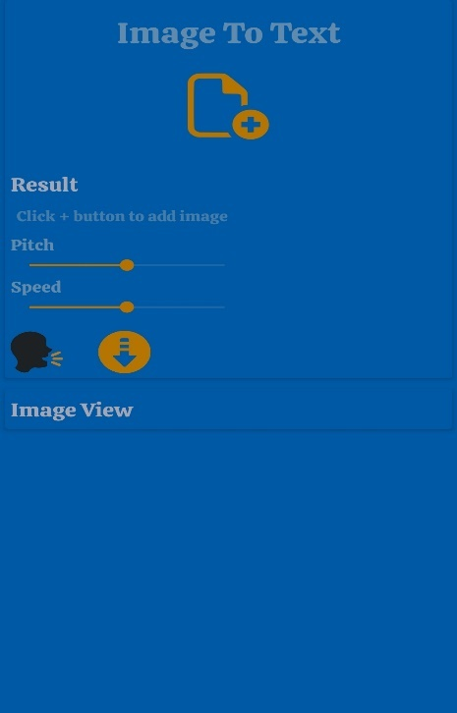

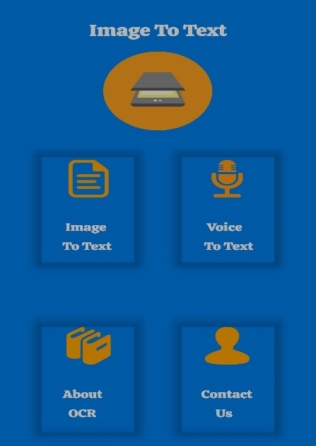

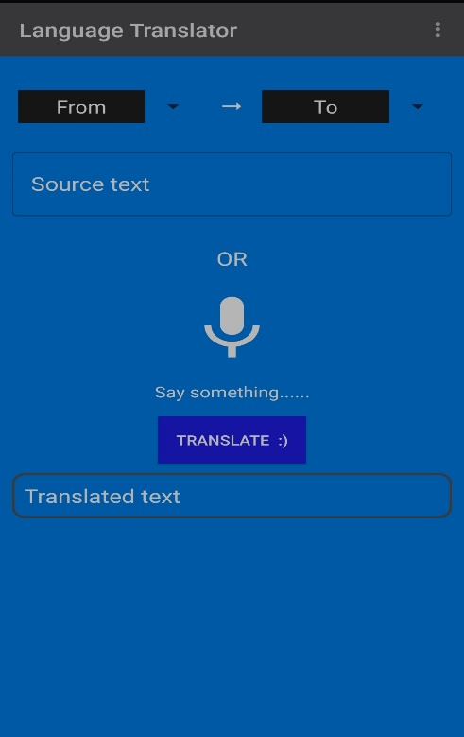

***Real-Time Object Detection and Recognition***

**4.5 Testing**

Testing is the process of evaluation of a system to detect differences between given input and expected output and also to assess the feature of the system. Testing assesses the quality of the product. It is a process that is done during the development process. .

**4.5.1 Strategy Used**

Tests can be conducted based on two approaches –

* Functionality testing
* Implementation testing

The texting method used here is Black Box Testing. It is carried out to test functionality of the program. It is also called ‘Behavioral’ testing. The tester in this case, has a set of input values and respective desired results. On providing input, if the output matches with the desired results, the program is tested ‘ok’, and problematic otherwise.

***Real-Time Object Detection and Recognition***

**Chapter 5.Conclusion**

Conclusion



**5.1 Conclusion**

In the existing system, we have google translator which utilizes internet connectivity whereas internet may not be available all the time and there are also many android application available that may not support all the functionalities like scanning text, speech recognition and translates the text and which are applicable for specific and limited languages which are not useful for all the users. So here in the proposed system where we will be implementing translation with support all the functionalities like scanning text, speech recognition and translates the text and includes the languages which are popular in our country as well as popular all over the world. The advantage of this application is it doesn’t require internet connectivity.

**5.2 Limitations of the Work**

* It isn’t perfect: While dictation technology is powerful tool, it is still in the early days which means there are some gaps in its overall performance.
* Because it produces verbatim text only, you can end up with the in accurate or awkward transcript or missing specific question.
* Require input because translator lacks complete accuracy, some human edits to the speech data is required for optimal usage.

***Real-Time Object Detection and Recognition***

**5.3 Suggestion and Recommendations for Future Work**

* The Model would be trained for detecting more number of objects.
* SNS service will be integrated in this project for alert notification when an unwanted object is detected.
* Currently, the bounding box technique is used which is bounding the targeted object within a rectangle. In future , Segmentation will be used.

**Bibliography**

* + <https://www.servetel.in/blog/speech-to-text-uses-in-contact-centre/>
  + [https://www.researchgate.net/publication/345195645_Different_Methods_Review_for_Spe](https://www.researchgate.net/publication/345195645_Different_Methods_Review_for_Speech_to_Text_and_Text_to_Speech_Conversion) [ech_to_Text_and_Text_to_Speech_Conversion](https://www.researchgate.net/publication/345195645_Different_Methods_Review_for_Speech_to_Text_and_Text_to_Speech_Conversion)
  + <https://iopscience.iop.org/article/10.1088/1757-899X/844/1/012039/pdf>
  + <https://www.scriptix.io/speech-to-text/>

<https://aws.amazon.com/what-is/speech-to-text/>

***Real-Time Object Detection and Recognition***

**Guide Interaction Sheet**



|  |  |  |
| --- | --- | --- |
| **Date** | **Discussion** | **Action Plan** |
|  |  |  |
|  | Discussed about the title of the | Language Translator App. |
| 1/08/2022 |  |
| Project |
|  |  |
|  |  |
|  |  |  |
| 03/08/2022 | Discussion on the technology to be | Google Trans , OCR and |
|  | used for language translator. | other tools were finalized |
| 17/08/2022 | Discussion of the creation of | Gathering of information for |
|  | synopsis of the project | synopsis creation |
|  |  |  |
|  | Suggestions on how to do a literature | Many research papers were |
| 27/08/2022 | survey and preliminary investigation | read , understood and their |
|  | on the topic | abstract were to be written. |
|  |  |  |
|  | Discussion on the implementation of | Using Google Trans and other |
| 12/09/2022 | tools, we decided to |
|  | the project | implement detection. |
|  |  |
|  |  |  |
|  | Discussion on the objective of the | Decided to Include the logic |
| 29/09/2022 | project | of converting source language |
|  |  | to desired language. |
|  |  |  |
|  | Scope for the project. | Took steps for adding and |
| 10/10/2022 |  | Modifying the application. |
|  |  |  |
|  |  |  |
|  | Worked on database. | Action taken that for each |
|  | user an entry must be made |
| 24/10/2022 |  |
| in the database so that count |
|  |  |
|  | can be made easy |
|  |  |
|  |  |  |
|  |  | Decided to write the content |
| 15/11/2022 | Discussion on project documentation | and integrate it in the proper |
|  |  | fomat of the report |
|  |  |  |

***Real-Time Object Detection and Recognition***